Axis & Allies: Tips & Tricks

1. Use poker chips, your own printed banknotes or banknotes from older editions as IPC.

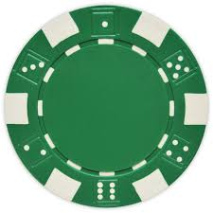 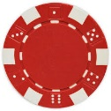 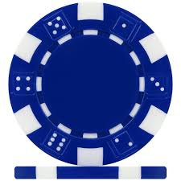

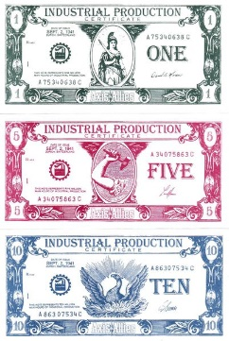

1. Place one die per plane in the zone that the plane attacks in phase 2 "Combat Move", to record how much movement the plane has left, to facilitate landing in phase 4 "Non-Combat Move".

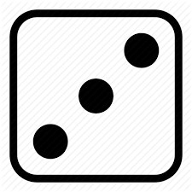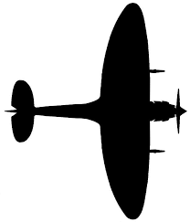

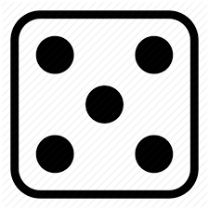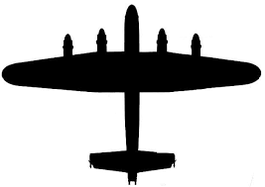

|  |  |  |  |  |  |  |
| --- | --- | --- | --- | --- | --- | --- |
|  | SU | GER | UK | JP | US | Victory  Check |
| PU (1) | Bildresultat fÃ¶r count system dashes | Bildresultat fÃ¶r count system dashes | Bildresultat fÃ¶r count system dashes | Bildresultat fÃ¶r count system dashes | Bildresultat fÃ¶r count system dashes | Bildresultat fÃ¶r count system dashes |
| CM (2) | Bildresultat fÃ¶r count system dashes | Bildresultat fÃ¶r count system dashes | Bildresultat fÃ¶r count system dashes | Bildresultat fÃ¶r count system dashes | Bildresultat fÃ¶r count system dashes |
| C (3) | Bildresultat fÃ¶r count system dashes | Bildresultat fÃ¶r count system dashes | Bildresultat fÃ¶r count system dashes | Bildresultat fÃ¶r count system dashes | Bildresultat fÃ¶r count system dashes |
| NCM (4) | Bildresultat fÃ¶r count system dashes | Bildresultat fÃ¶r count system dashes | Bildresultat fÃ¶r count system dashes | Bildresultat fÃ¶r count system dashes | Bildresultat fÃ¶r count system dashes |
| M (5) | Bildresultat fÃ¶r count system dashes | Bildresultat fÃ¶r count system dashes | Bildresultat fÃ¶r count system dashes | Bildresultat fÃ¶r count system dashes | Bildresultat fÃ¶r count system dashes |
| CI (6) | Bildresultat fÃ¶r count system dashes | Bildresultat fÃ¶r count system dashes | Bildresultat fÃ¶r count system dashes | Bildresultat fÃ¶r count system dashes | Bildresultat fÃ¶r count system dashes |

1. Keep a record for tracking whose turn and phase it is, as per below:  
     
   In this example, it is Germanys 7th turn, phase 4 “Non-Combat Move”.
2. In phase 2 “Combat Move”, keep track of from which territory units are attacking and which territory they are attacking. This will facilitate phase 3 “Combat”, so one knows which fights have been resolved, and which territories units can retreat to.  
     
   Manchuria, French Indo-China → China  
   SZ37 → SZ38  
     
   In a similar way, you can track planes too (and/or use *Tip II*). It is sufficient to denote the territory, number of units, unit type (F for fighter, B for bomber) and a symbol (for example ) to denote strategic bombing raids.  
     
   Planes:

Russia 1B   
Buryatia 1B

China 3F 2B

1. Players in the opposing team that are not involved in fighting during a turn, can take a well-earned bathroom break and plan their strategies for their own upcoming turn!
2. In phase 2 “Combat Move” place a chip (for example a white poker or backgammon chip) to note areas of combat on the game board. This way, resolving combat will be easier, and you can keep track of contested territories at a glance during this phase and upcoming phases.

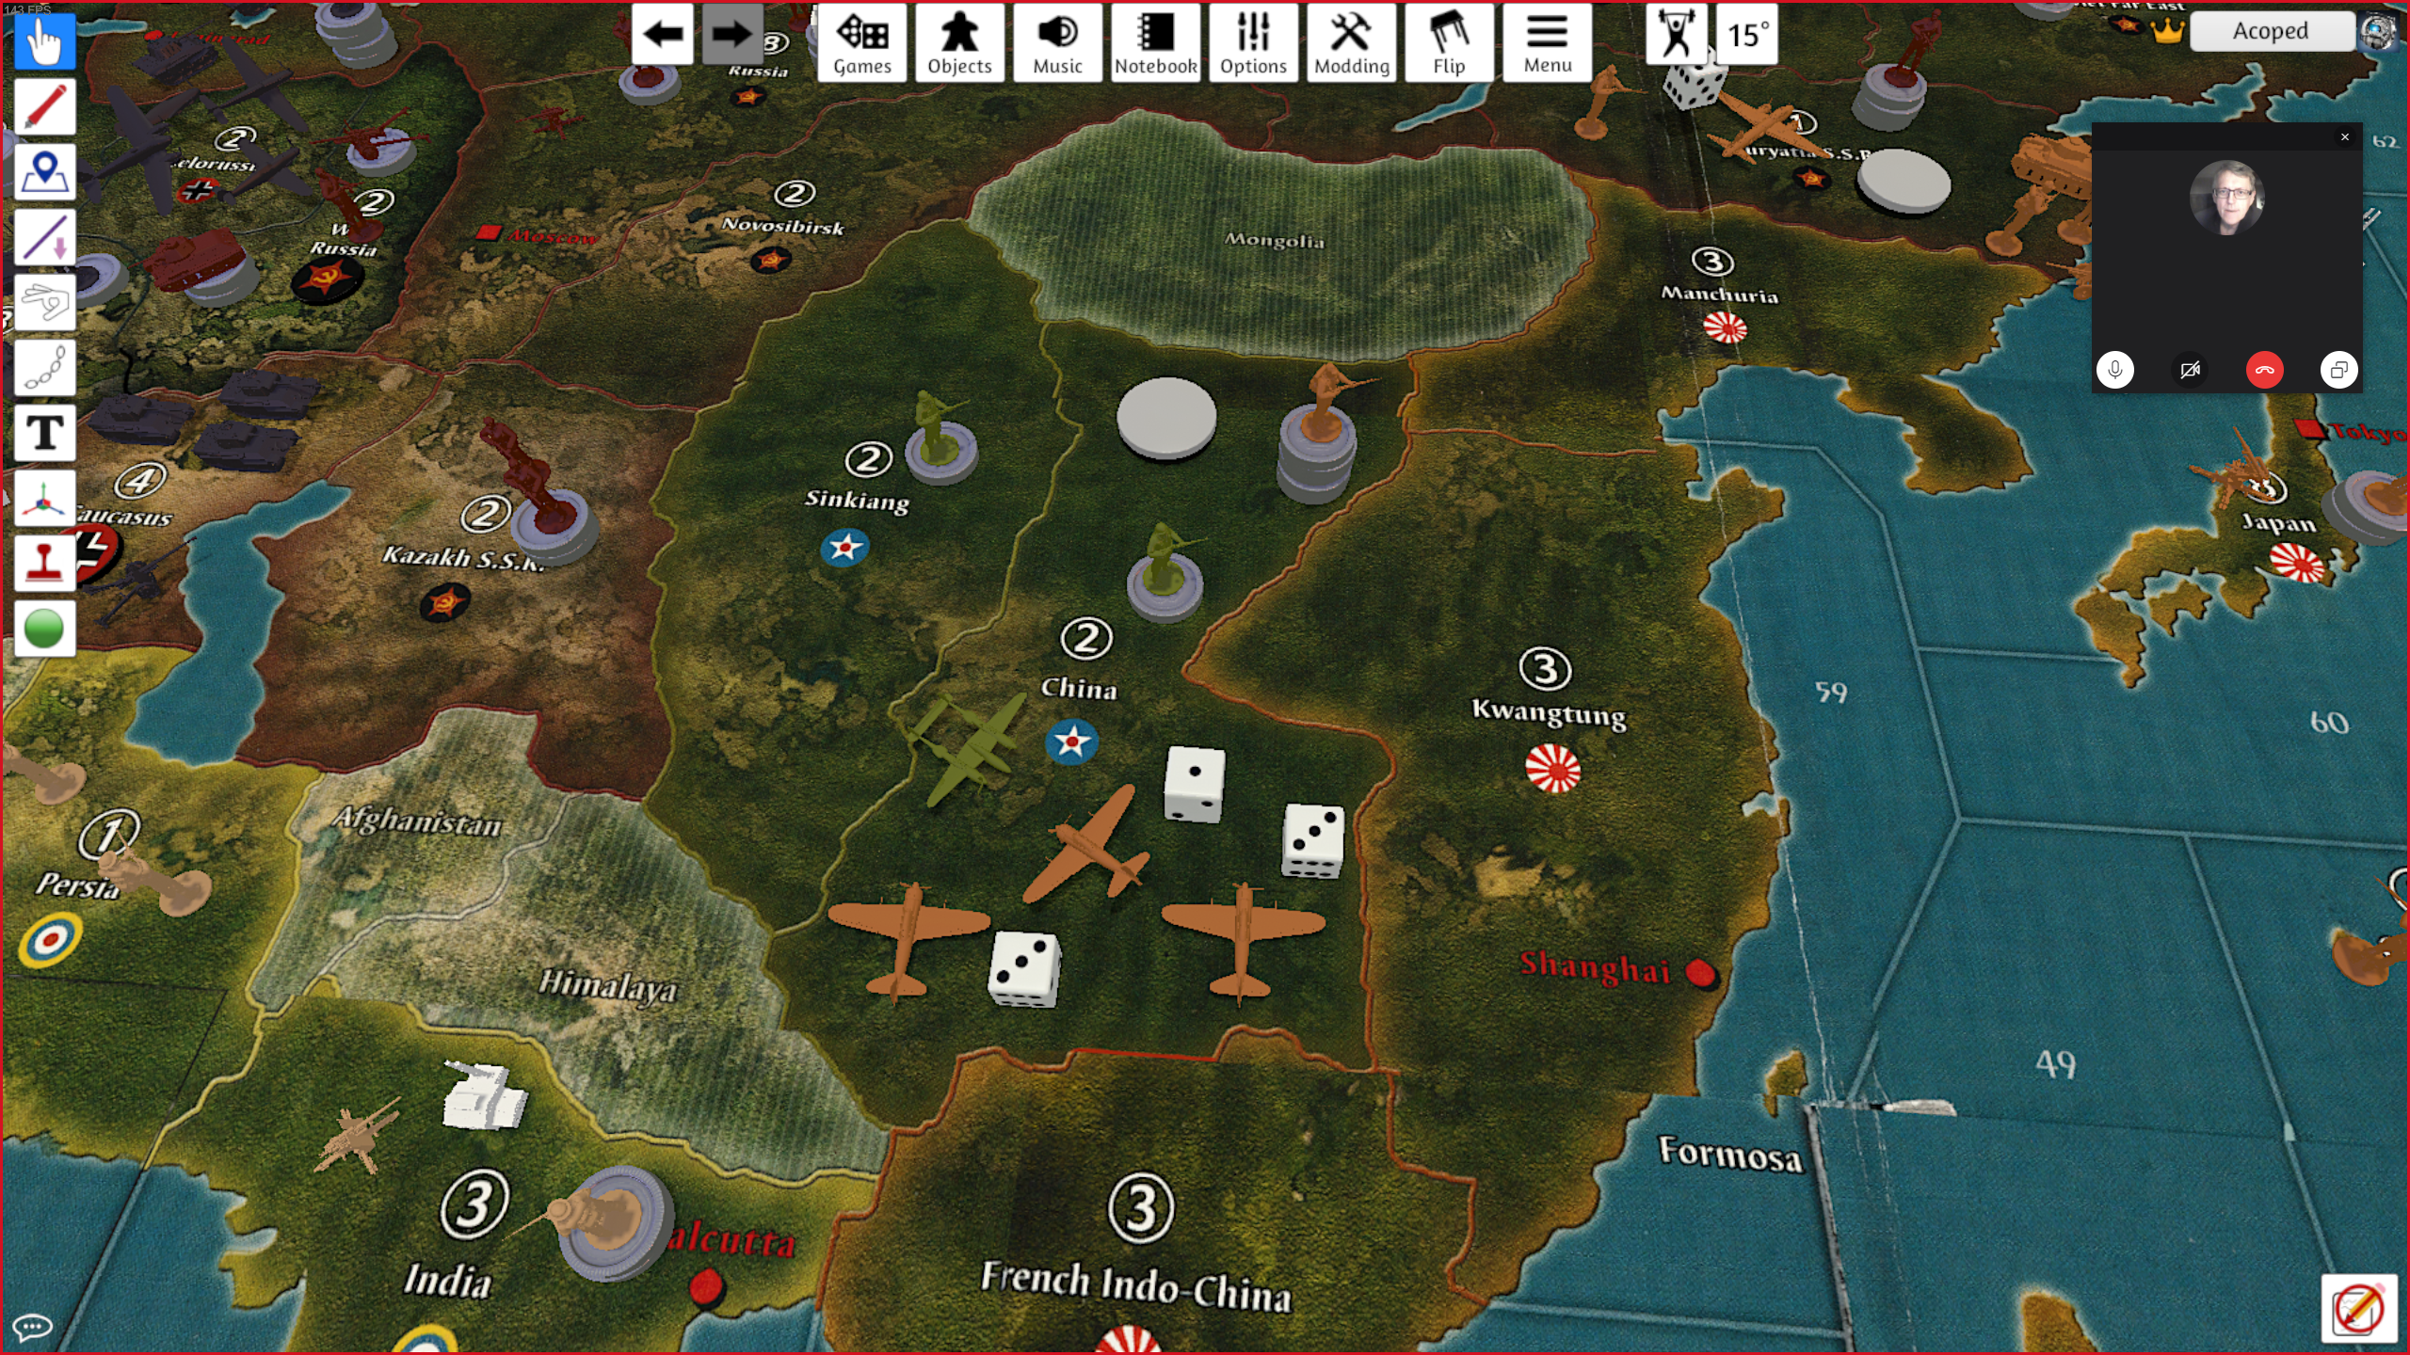

1. Create an ”Amphibious Assault Strip” and place it above the Combat Strip, to differentiate units attacking via an amphibious assault. Those units cannot retreat.

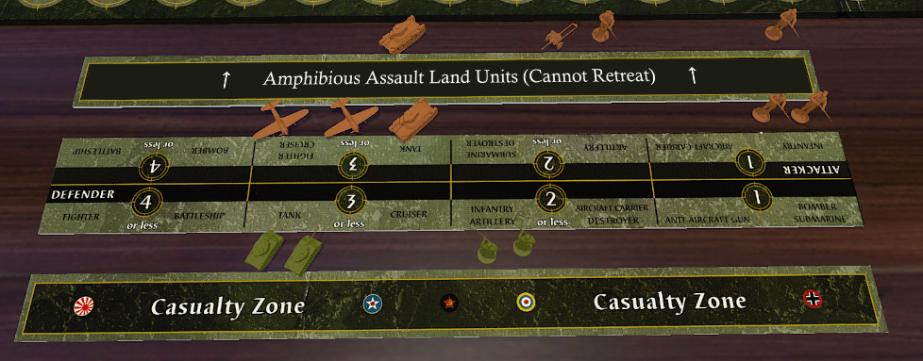

1. Use different colored markers (again, poker or backgammon chips) to represent how many Victory Cities the Axis and the Allies have, respectively. The IPC counter is perfect for this!  
     
   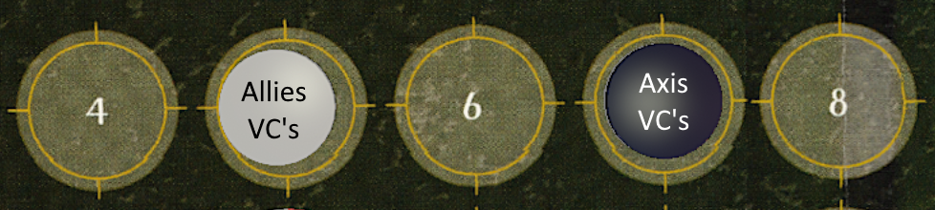

Feel free to distribute and edit/improve this document in any medium!

I would be happy if you credited:

Andreas K  
reddit.com/u/Acoped